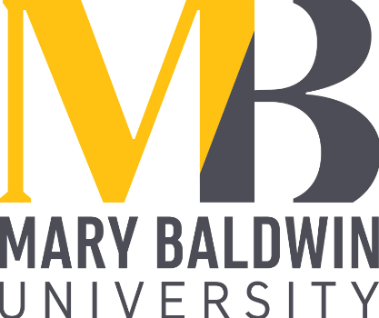

INTENT TO STUDY ABROAD

This form is required for students who intend to study abroad in a program other than May term while enrolled at Mary Baldwin University. Please complete this form and submit to the Spencer Center by:
November 1st for spring semester; March 1st for fall semester; April 1st for summer study abroad.
Note that some programs may have earlier deadlines.
MBU students must be in good academic and disciplinary standing to be eligible for study abroad.

Name______________________ I.D.________________________ Date_______________________

Date of Birth__________________ Major(s) __________________________Minor(s) _________________________

Expected date of graduation__________________ Cumulative GPA ___________ Advisor ___ ____________________

Circle one: MBCW VWIL PEG UC Other ___________________

Home Address ___________________________________________________________________________________

Name of Study Abroad Program_______________________________________________________________________

Program Address_______________________________________________________ Phone _____________________

Contact Person___________________________________________________________________________________

E-mail address___________________________________________________________________________

Program dates____ Term(s) abroad _________ Return to MBU_________________

University where classes will be taken (if applicable) ____ __________________________________________________

International study program discipline, course number, and course title | Credit from int’l study program | College requirements to which courses apply

Any courses other than those specifically approved in advance may not transfer. Upon your return, you must present your unopened study abroad transcript to the Registrar in order to have your credits transferred.

Approvals required (in order shown):

- Major Faculty Advisor(s)__________________________________________________________

- Minor Faculty Advisor(s) (if taking courses related to minor)______________________________

(3) Registrar________________________________________________________________

(4) Assistant Director of the Spencer Center______________________________________

PASSPORT INFORMATION

NAME (as printed on passport) _ ______________________________________________________

PASSPORT number __________________________________Expiration date ________________

ISSUING COUNTRY United States_________________________________

Attach to this form a photocopy of the photo page of your passport.

IMPORTANT REMINDERS
1. In order to obtain credit for study abroad, you must obtain pre-approval by both your advisor and the Registrar.
2. If you do not know this information before you leave, email the registrar, the Office of the Registrar, as soon as you learn it: registrar@marybaldwin.edu.
3. You must send the Assistant Director of the Spencer Center your address, telephone number, and email address as soon as you are given one so that we have a way to contact you.
4. Request a transcript from your study abroad institution before you return to the United States.
5. Check in with the Assistant Director of the Spencer Center for Civic and Global Engagement after arriving, while you are abroad and when you return to campus.
6. Submit the transcript from your study abroad program to the registrar’s office as soon as it becomes available.

Signature _______________________________________________ Date_______________________

Parent/Guardian Signature _________________________________ Date_______________________
(if student is under 18)

